

1097 NACO AIDS Helpline

Version 1.5

# Document Control

## Review and Approvals

|  |  |  |  |
| --- | --- | --- | --- |
|  | **Designation** | **Name** | **Date** |
| **Author** | System Admin | Vijay Kumar N | 07-Au-2023 |
| **Reviewed by** | Manager | Saleem Syed | 08-Au-2023 |
| **Approved by** | Program Manager | Intekhab A | 08-Au-2023 |

## Distribution

|  |  |  |
| --- | --- | --- |
| **Stake Holder’s Name** | **Holder’s Designation** | **Issue Date & Location where this document will be stored** |
| Madhu Telugu | NACO Ops Head |  |
| Nithin Rathnam | Operation Manager |  |
| Reshma Ravindran Pillai | Shift Supervisor |  |
|  |  |  |
|  |  |  |
|  |  |  |
|  |  |  |
|  |  |  |

## Amendment Record

|  |  |  |  |  |
| --- | --- | --- | --- | --- |
| **No** | **Date** | **Section(s)** | **Issue No.** | **Description** |
| 1 | 02-Mar-2015 | All | 1.0 | Initial Version |
| 2 | 24-Dec-2015 |  | 1.1 | Updated SCON architecture |
| 3 |  |  | 1.2 | When Solan location was added |
| 4 |  |  | 1.3 | When GR module was added |
| 5 | 07-Aug-2023 |  | 1.5 | Implementation of Backup solution |

**Table Of Contents**

1. Document Control 2

1.1 Review and Approvals 2

1.2 Distribution 2

1.3 Amendment Record 2

2. Purpose 4

3. Scope 4

4. Reference 4

5. Overview 4

6. Service Continuity Plan Preparation 5

6.1 Business Impact Analysis 5

6.2 Service Continuity Plan Assumptions 5

6.3 Organization Roles and Responsibilities 5

6.4 Critical Contacts 6

6.5 Monitor and Review 6

7. Disaster Recovery Management Plan 6

8. SCON and Disaster Recovery Network Diagrams 6

# Purpose

The processes and procedures that are carried out by an organization to ensure that essential business functions of 1097 NACO helpline continue to operate during an unforeseen circumstances and after.

By having a BCP, organizations seek to protect their mission critical services and give themselves their best chance of survival. This type of planning enables them to re-establish services to a fully functional level as quickly and smoothly as possible. Business continuity plan generally cover most or all of an organization’s critical business processes and operations.

# Scope

Implementing and providing on-going support for a disaster recovery solution for 1097 National AIDs Helpline and thus mitigate the loss of services during an unforeseen circumstances by considering the following

* Identifying critical business functions
* Identifying business risks
* Specifying data backup and recovery plan
* Specifying communication plan

# Reference

Master Service Agreement document with PSMRI

# Overview

1097 Helpline is operational 24X 7 X 365 days a year and accessible through toll-free 4 digit number (1097) across India from any landline/mobile phone. Call center agents operate from four locations within India (Hyderabad, Guwahati, Jaipur and Solan).

Staffed by trained & experienced counselors provide services like general information on HIV / AIDS, causes of infection, preventions, and addresses issues of resulting stigma, depression etc. Referral services like referrals to ICTCs, ART centre, Counseling specialists and also feedback about specific incidents etc., The above services are provided in 12 Indian languages and anonymity and confidentiality of caller is maintained throughout the process.

However, at times the picture is not as rosy as it is supposed to be. The caller / beneficiary may have grievances against the services provided by AIDS delivery system. The NACO’s Grievance Redressal System (GR) is an attempt to facilitate the callers / beneficiaries to register their complaints through 1097 NACO Helpline and then be intimated to an action taking authority to take the remedial measures within a stipulated time period.

# Service Continuity Plan Preparation

## Business Impact Analysis

Refer attached spread sheet (1097NACO_BCP&DR Plan_Scenarios) for Business Unit / Function, Business Process, Responsible person and Recovery Time Objective (RTO) details

## Service Continuity Plan Assumptions

* All the required hardware, ISP lines and software are running as expected
* Latest application source code and data backups are up-to-date
* All the responsible staff are available to perform the service continuity plan

## Organization Roles and Responsibilities

### Contact Information

|  |  |  |  |
| --- | --- | --- | --- |
| Name | Role/Title | Work Phone Number | Mobile Phone Number |
| Intekhab A | Manager DBC | 9908079854 |  |
| Saleem Syed | Manager IT Infra | 9502811577 |  |
| Shashank K | Product manager | 8310106023 |  |
| Avinash S | L2 Lead | 9515116982 |  |
| Vijay Kumar N | System Admin | 9154622513 |  |
| Suraya Ramana | Network Admin | 9515264766 |  |
| Sachin Kadam | System Admin | 9404571992 |  |

## Critical Contacts

|  |  |  |
| --- | --- | --- |
| **Name** | **Description** | **Contact** |
| Madhu Telugu | 1097 Ops Manager | madhukumar.telugu@piramalswasthya.org |
| Saleem Syed | IT Infra Manager | syed.saleem@piramalswasthya.org |
| Intekhab A | Manager DBC | intekhab.alam@piramalswasthya.org |

## Monitor and Review

Monitor and review is carried out by performing BCP drills on periodical basis and

Providing evidences at required levels etc

# Disaster Recovery Management Plan

Service continuity items, Issue, Plan and Execution steps and RTO are provided in

|  |  |  |  |
| --- | --- | --- | --- |
| Step | Owner | Duration | Components |
| Determine whether failback to original Data Center will be pursued | DR TEAM | 8 Hours | * Restoration procedures determined |
| If Original data center restored | DR TEAM | 3 Days | * Server Farm level recovery |
| Complete Failback | DR Team | 3 Days | * Failback steps executed, including handoffs between key dependencies |
| Test Failback | DR Team | 1 Day | * Tests assigned and performed * Results summarized and communicated to group * Issues (if any) communicated to group |
| Determine whether failback was successful | DR TEAM | 1 Day | * Declaration of successful failback and communication to stakeholder group. * Disaster recovery procedures closed. * Results summarized, post mortem performed, and DRP updated (as needed). |

# SCON and Disaster Recovery Network Diagrams

Please find attached 1097 Network diagram and server IP address of Primary and secondary servers

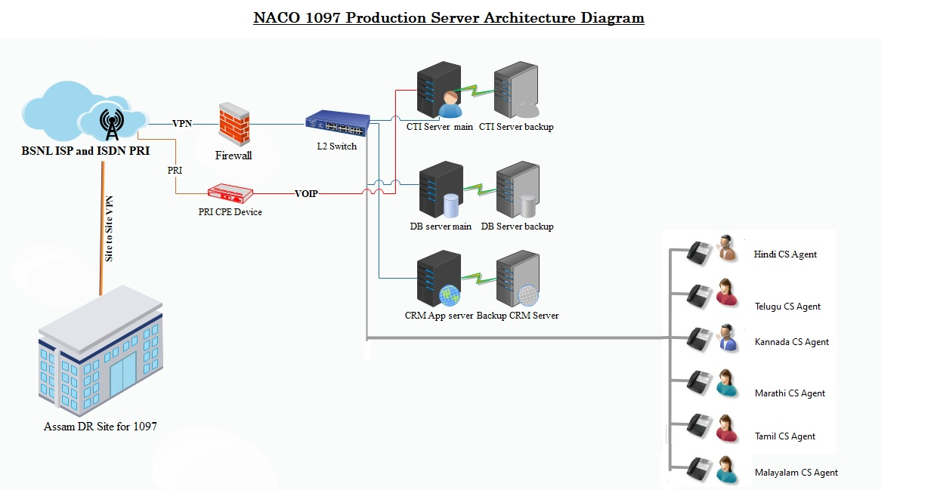

**Server IP address**

|  |  |  |  |
| --- | --- | --- | --- |
| **S.No** | **Location** | **Server** | **IP** |
| 1 | Hyderabad | CRM App Primary | 192.168.35.218 |
| 2 | Hyderabad | CRM App Secondary | 192.168.35.151 |
| 3 | Hyderabad | CTI Czentrix primary | 192.168.35.239 |
| 4 | Hyderabad | CTI Czentrix Secondary | 192.168.45.55 |
| 5 | Hyderabad | DB Server primary | 192.168.35.218 |
| 6 | Hyderabad | DB Server secondary | 192.168.45.219 |
| 7 | Guwahati(Assam) | CTI Czentrix Server | 192.168.36.4 |
| 8 | Guwahati(Assam) | CRM App Server | 192.168.36.6 |
| 9 | Guwahati(Assam) | DB Server | 192.168.36.5 |